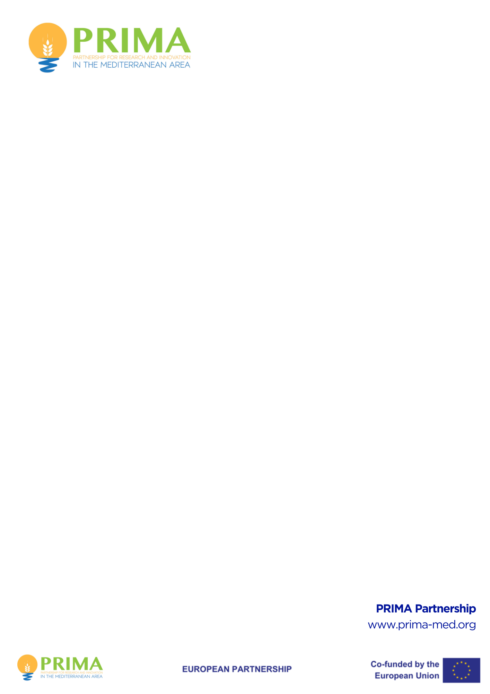

PRIMA PRIZE FOR
WOMAN GREENING FOOD SYSTEMS IN THE MEDITERRANEAN

WP2025

PRIZE APPLICATION TEMPLATE

Administrative Form (Part I)

- Project General Information

Topic: PRIMA-2025 PRIZE FOR WOMAN GREENING FOOD SYSTEMS IN THE MEDITERRANEAN

Acronym
The title should be no longer than 200 characters (with spaces) and should be understandable to the non-specialist in your field.
Application title

Key Words

The contestant must select minimum 3 and maximum 6 keywords. Keywords in Part I, II and Electronic Submission System must be the same.
Abstract

The abstract (summary) should, at a glance, provide the reader with a clear understanding of the content of the application and its relation to the objectives of the contest. It must be short and precise and should not contain confidential information. Please use plain typed text, avoiding formulae and other special characters. The abstract must be written in English. The limit of characters is 4,000 (including spaces and line breaks). Font size is 11.
The Abstract in Part I document and the one on the ESS (English version) must be the same.

Characters Limit: 4,000

- Contestant General Information
Lead Contestant - Organization

Legal Name of the Organization:

Participant Identification Code (PIC):

Country of the Organization:

Legal Status of your Organization:

Public body ……………………………………
Non-profit ……………………………………
International organization
International organization of European interest………………………...
Secondary or Higher education establishment
Research organization …………………………………….
Small and Medium-sized Enterprises (SMEs)
Legal Person………………………………………………………………………………………….

Person in Charge of the Application (Lead Contestant)
First Name
Last Name
E-Mail | Please indicate your active email for future communication
Position in Organisation | Please indicate the position of the Contact Point above in the organization
Nationality

List of Participants (if any)
Participant No | Name of the Contact Person | Country | Organisation Name | PIC¹
Partner 1*
Partner 2
Partner 3
* You can add extra lines/rows for additional partners
DECLARATION
I hereby declare that:
- In case of several contestants, the lead contestant declares to have the explicit consent of all contestants on their participation and on the content of this application.
- The information contained in this application is correct and complete.
- I have fully read and understood and agree to the official Rules of Contest (RoC).
- I am fully eligible and not excluded from participation in accordance with the Rules of Contest.
- All other contestants have confirmed that they are fully eligible and not excluded from participation in accordance with the Rules of Contest.
- This application complies with ethical principles (including the highest standards of research integrity — as set out, for instance, in the European Code of Conduct for Research Integrity — and including, in particular, avoiding fabrication, falsification, plagiarism or other research misconduct).

Personal data protection

Your submission to the prize application will involve the recording and processing of personal data (such as your name, address and CV), which will be processed pursuant to Regulation (EC) No 45/2001 on the protection of individuals with regard to the processing of personal data by the Community institutions and bodies and on the free movement of such data. Unless indicated otherwise, your replies to the questions in this form and any personal data requested are required to assess your prize application in accordance with the specifications of the prize contest and will be processed solely for that purpose.
Details concerning the processing of your personal data are available on the privacy statement at the page:
https://commission.europa.eu/funding-tenders/procedures-guidelines-tenders/data-protection-public-procurement-procedures_en
Contestants may lodge a complaint about the processing of their personal data with the European Data Protection Supervisor at any time

PIC: Participant Identification Code (PIC) - https://ec.europa.eu/info/funding-tenders/opportunities/portal/screen/how-to-participate/participant-register-search

